**What were the causes and consequences of the First Intifada?**

**Lesson 11**

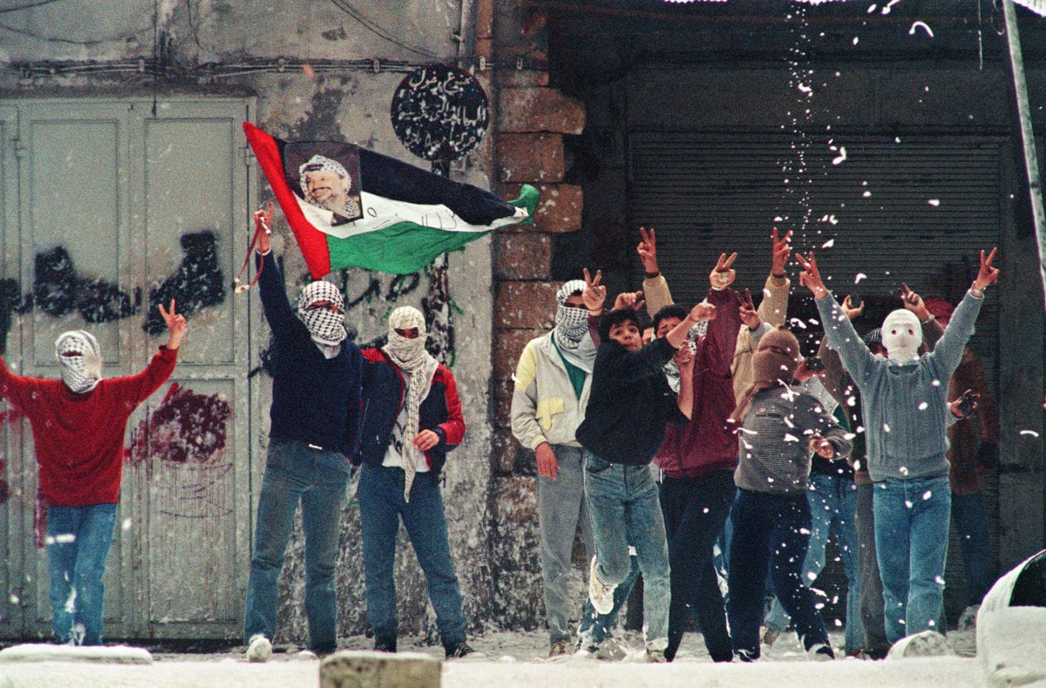

**By the end of this lesson, you should be able to:**

Describe what happened during the First Intifada

Explain the causes of the First Intifada

Discuss the consequences of the First Intifada

**Keywords**

Intifada

First Intifada, 1987-1993

Grassroots movement

Jabalia camp

Boycott

**Knowledge check!**

1)What were the consequences of the June 1967 War for the West Bank and Gaza?

**First Intifada, 1987-1993**

*A massive uprising of Palestinians against Israel’s ongoing occupation of the West Bank and Gaza*

**Palestinian living conditions in the West Bank and Gaza**

As we have seen, life was **very difficult** for Palestinians in the West Bank and Gaza after 1967. Palestinians **lost their homes** whilst thousands of Israelis established **settlements.** Palestinians were also arrested and imprisoned by the Israeli military, often **without trial.** Daily harassments and beatings of Palestinians became routine

As the Palestinian population increased but the Palestinian share of the land was reduced, the West Bank and Gaza became **dangerously overcrowded** and **unhygienic** as a result

Also, due to the economic restrictions placed on Palestinians by Israeli rule, there were very few jobs available and as a consequence there was **high unemployment, particularly among the young.** Some Palestinians found work in Israel, but they were often **paid less** than their Israeli counterparts for doing a comparable job. Palestinians also had to pay a **higher rate of tax**, but did not have the same access to **medical or social services**

**Historian Benny Morris on life for Palestinians**

According to historian Benny Morris, life for Palestinians under Israeli occupation in the West Bank and Gaza at this time was characterised by “brute force, repression and fear, collaboration and treachery, beatings and torture chambers, and daily intimidation, humiliation, and manipulation" (Benny Morris, *Righteous Victims*, 1999)

**Increasing tension**

Between 1967 and 1987, **tension increased** between Palestinians and Israelisand there were numerous **attacks by both sides**. For example, on 11th March 1978, 38 Israelis (including 13 children) were killed by Palestinian nationalists. This is known as *The Coastal Road massacre.* In the same month, **1100 Palestinians and Lebanese** were killed during an Israeli invasion of south Lebanon, known as *Operation Litani*

With tensions at tipping point, on **8th December 1987**, four Palestinians were killed in a collision with an IDF truck in Jabalia refugee camp, Gaza. Jabalia was the largest Palestinian refugee camp and one of the most densely populated places on earth. For the Palestinians, this was the ***final straw***: the First Intifada now began

**Volcano activity**

**Questions**

Answer these questions using the information in this chapter:

-How did the First Intifada start?

-Which parts of Palestinian society took part in the demonstrations?

-How did Israel respond to the Palestinian demonstrations?

-Why was this criticised?

-What does UNLU stand for? What did the UNLU organise?

-When and why did the First Intifada end?

*Extension Question: Why is the First Intifada significant?*

**What happened during the First Intifada?**

On 8th December 1987, four Palestinians were killed in a collision with an IDF truck in Gaza. The **funerals** of these four Palestinians turned into **demonstrations** against Israeli occupation. Over the next few weeks, these demonstrations **spread** across Gaza and the West Bank

These were **widespread, grassroots demonstrations**: Palestinian men, women and children came together from all over, but they were not led by the PLO. **Most of this was peaceful and non-violent**, but stones and petrol bombs were also thrown by Palestinians at the IDF

-How did Israel respond?

The Israeli response to the Palestinian uprising across the West Bank and Gaza was **brutal violence**. Israel deployed **80,000 soldiers** and these soldiers even shot **peaceful protesters** and **beat Palestinian children**. In fact, **53 Palestinian children** were killed by IDF soldiers in the first year of the Intifada, and many more children had their **bones broken** by the IDF

-What did the international community say?

The international community said **this had to stop.** As a consequence, Israel switched to using plastic bullets instead, but these still caused **horrible injuries***.* By 1993, 1,200 Palestinians had been killed and 130,000 Palestinians had been injured in the uprising

-The Unified National Leadership of the Uprising (UNLU)

Palestinians were also **boycotting** Israel at this time. A boycott is the decision *not to use or buy something, usually for political reasons.* This is an important nonviolent expression of protest. Palestinianswouldn’t buy Israeli products, work in Israel or pay Israeli taxes. During the Intifada, a group of Palestinians created the Unified National Leadership of the Uprising (**UNLU**) to coordinate the demonstrations and boycotts

Eventually, talks between Israel and the PLO took place at the **Madrid Conference of 1991**. But it was not until **1993** that limited agreements were reached in the Oslo Accords

**The role of women**

Often the First Intifada is seen as a male uprising by Palestinian men and boys. But actually, women were **the backbone of the uprising.** They played a really important role in the First Intifada. In fact, one third of the Palestinians killed were women

Women in the West Bank and Gaza organised **demonstrations and boycotts** across the country, and they also coordinated **education and health services** for Palestinians at this time

Does this surprise you? Why or why not?

**Consequences**

The First Intifada had **huge human consequences**. 1,200 Palestinians were killed and 130,000 Palestinians were injured. On top of this, tens of thousands of Palestinians were imprisoned and many were **routinely tortured**. 160 Israelis were killed

On a daily level, the economies of both Israel and Palestine suffered enormously. Money was spent on **security rather than development**, which meant that businesses collapsed. For Palestinians, **schools were closed** for long periods and the unemployment levels only got higher. For Israelis, tourism suffered and **some Israelis started to question** the occupation of the West Bank and Gaza

On the other hand, the First Intifada had shown the **strength of the Palestinian movement**: even without the leadership of the PLO, the Palestinian people had united with mostly peaceful demonstrations and boycotts against the ongoing Israeli occupation

The First Intifada also brought **international attention** to the situation in Palestine-Israel: Israel was criticised by the international community for its **disproportionately violent response** to the Palestinian uprising

**Activity**

In small groups, summarise the consequences of the First Intifada in two lists, one showing negative consequences and the other showing positive consequences

**Debating activity**You are now going to be assigned a partner. You and your partner are either in ‘**support**’ or ‘**opposition**’ to the Israeli occupation of the West Bank and Gaza. You can spend a few minutes preparing your argument. Then you will join with another pair and have a debate  
 *What can you use from this lesson and other lessons to support your argument?*

*Which arguments do you find most convincing? Why?*

Make a note of the best points raised by the other side

Opposition to Israeli occupation of the West Bank and Gaza:

The West Bank and Gaza is Palestinian land. Palestinians have lived here for centuries. UN Resolution 242 says that Israel should withdraw from the territory it occupied during the June 1967 War, not keep building on it.

Support for Israeli occupation of the West Bank and Gaza:

Israel took control of the West Bank and Gaza in the June 1967 War. This was a military victory for Israel. Some of this land has huge religious significance for Zionists, so Israeli settlers should be able to build homes and live there now.

**Check your knowledge!**

What were three causes of the Intifada?

How long did the First Intifada last?

What were three consequences of the Intifada?